Prelucrarea datelor experimentale – Seminar 1

Rezolvaţi exerciţiile de mai jos conform exemplului prezentat pentru tabelul 1:

Table 1
1 | 1.059
2 | 2.776
3 | 5.636
4 | 9.287
5 | 12.938
6 | 18.37
7 | 24.41
8 | 33.286
9 | 42.072
10 | 50.612

a. | y = 1.3343e^{0.3998x} | R² = 0.9383
b. | y(x)= 0,5094x² - 0,0875x + 0,9143 | R²= 0,9991
c. | y = 5.5158x - 10.292 | R² = 0.9474

Grafic realizat în MsExcel cu datele din tabelul 1:
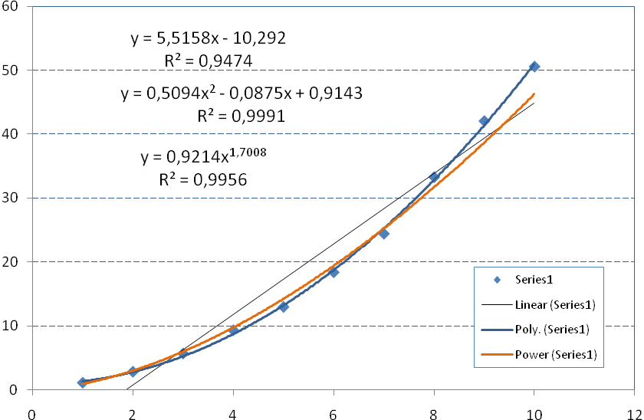
Trendline

Table 2
1 | 1.075
2 | 1.833
3 | 3.084
4 | 4.842
5 | 6.958
6 | 9.367
7 | 12.924
8 | 16.986
9 | 19.955
10 | 24.321

a. | y(x)= | R²=
b. | y(x)= | R²=
c. | y(x)= | R²=

Table 3
1 | 2.703
2 | 6.05
3 | 10.424
4 | 16.712
5 | 25.685
6 | 35.637
7 | 47.782
8 | 59.48
9 | 73.948
10 | 84.019

a. | y(x)= | R²=
b. | y(x)= | R²=
c. | y(x)= | R²=

Table 4
1 | 0.947
2 | 1.946
3 | 3.44
4 | 5.361
5 | 7.3
6 | 9.961
7 | 13.389
8 | 16.99
9 | 20.098
10 | 24.647

a. | y(x)= | R²=
b. | y(x)= | R²=
c. | y(x)= | R²=

Table 5
1 | 1.987
2 | 4.997
3 | 9.894
4 | 15.518
5 | 23.821
6 | 31.886
7 | 41.864
8 | 57.128
9 | 69.054
10 | 85.66

a. | y(x)= | R²=
b. | y(x)= | R²=
c. | y(x)= | R²=

Table 6
1 | 1.928
2 | 5.073
3 | 9.913
4 | 16.217
5 | 25.66
6 | 36.934
7 | 46.381
8 | 60.125
9 | 77.477
10 | 91.527

a. | y(x)= | R²=
b. | y(x)= | R²=
c. | y(x)= | R²=

Table 7
1 | 0.453
2 | 0.673
3 | 0.88
4 | 1.235
5 | 1.454
6 | 1.896
7 | 2.149
8 | 2.73
9 | 2.974
10 | 3.402

a. | y(x)= | R²=
b. | y(x)= | R²=
c. | y(x)= | R²=

Table 8
1 | 1.603
2 | 3.92
3 | 7.766
4 | 11.785
5 | 17.853
6 | 24.256
7 | 32.364
8 | 39.099
9 | 48.591
10 | 57.727

a. | y(x)= | R²=
b. | y(x)= | R²=
c. | y(x)= | R²=

Table 9
Obs. nr. | x | y
1 | 0.99 | 90.01
2 | 1.02 | 89.05
3 | 1.15 | 91.43
4 | 1.29 | 93.74
5 | 1.46 | 96.73
6 | 1.36 | 94.45
7 | 0.87 | 87.59
8 | 1.23 | 91.77
9 | 1.55 | 99.42
10 | 1.4 | 93.65
11 | 1.19 | 93.54
12 | 1.15 | 92.52
13 | 0.98 | 90.56
14 | 1.01 | 89.54
15 | 1.11 | 89.85
16 | 1.2 | 90.39
17 | 1.26 | 93.25
18 | 1.32 | 93.41
19 | 1.43 | 94.98
20 | 0.95 | 87.33

a. | y(x)= | R²=
b. | y(x)= | R²=
c. | y(x)= | R²=

Table 10
825 | 40
830 | 42
890 | 49
895 | 46
890 | 44
910 | 48
915 | 46
960 | 43
990 | 53

a. | y(x)= | R²=
b. | y(x)= | R²=
c. | y(x)= | R²=

