How to create a database? How to create a table?

https://www.studentstutorial.com/php/how-to-create-table-in-phpmyadmin
To start any kind of project in PHP you need to create a table in PhpMyAdmin.
To create a table in PhpMyAdmin first you have to create a database.

Step 1
First of all start your XAMPP or WAMPP server. Then you find a page like this

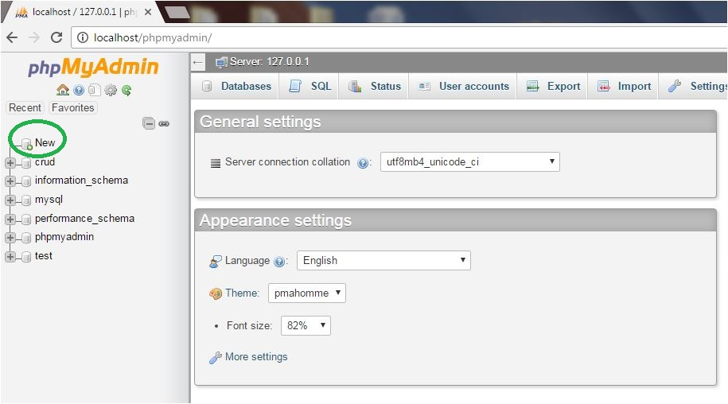
Then click on the new button that is available on the sidebar of that page.

Step 2
After click on the new button you find a page like that
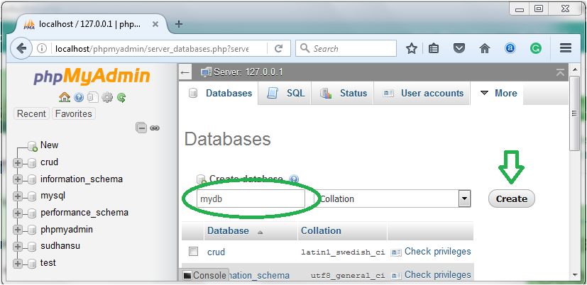
Here put a name of your own choice on the create database field and click on the create button and you get a successful message on the screen that you create database successfully and will appear in the database list.
Note: You can’t create table if you not have a database so first create the database.

Step 3
Click on the database name in which under you create a table. After click on the database name you find a page like that.
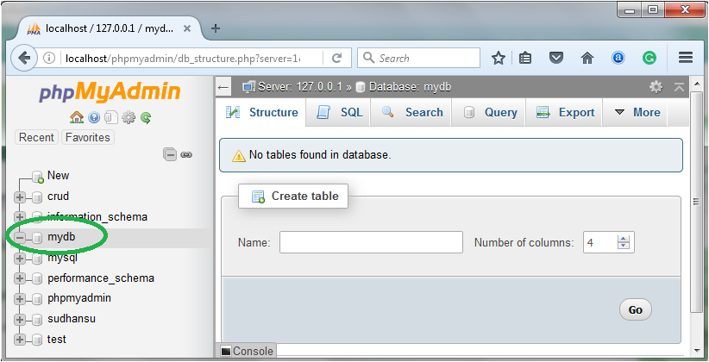
Here you have two option to create table first one is using structure and second one is using SQL.If you want to create table in structure option then put your table name on the create table name field and choose columns and click on the go button. If you want to create a table by writing SQL Query simply click on the SQL button on the page and write your query and click on the GO button.

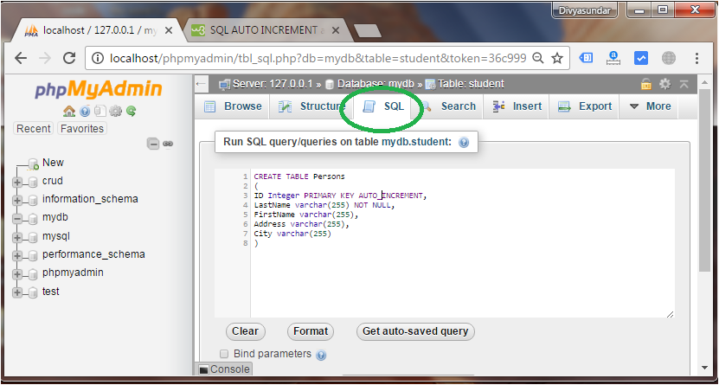
If your SQL query is correct you find a page like that.

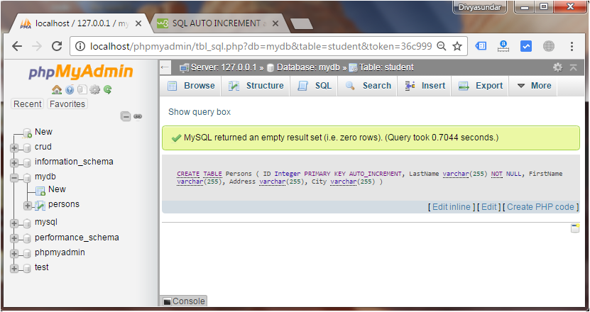

How can I use the relation table in Query-by-example?
Here is an example with the tables persons, towns and countries, all located in the database “mydb”.
CREATE TABLE REL_countries (
country_code char(1) NOT NULL default '',
description varchar(10) NOT NULL default '',
PRIMARY KEY (country_code)
) ENGINE=MyISAM;

INSERT INTO REL_countries VALUES ('C', 'Canada');

CREATE TABLE REL_persons (
id tinyint(4) NOT NULL auto_increment,
person_name varchar(32) NOT NULL default '',
town_code varchar(5) default '0',
country_code char(1) NOT NULL default '',
PRIMARY KEY (id)
) ENGINE=MyISAM;

INSERT INTO REL_persons VALUES (11, 'Marc', 'S', 'C');
INSERT INTO REL_persons VALUES (15, 'Paul', 'S', 'C');

CREATE TABLE REL_towns (
town_code varchar(5) NOT NULL default '0',
description varchar(30) NOT NULL default '',
PRIMARY KEY (town_code)
) ENGINE=MyISAM;

INSERT INTO REL_towns VALUES ('S', 'Sherbrooke');
INSERT INTO REL_towns VALUES ('M', 'Montréal');
To setup appropriate links and display information:
- on table “REL_persons” click Structure, then Relation view
- for “town_code”, choose from dropdowns, “mydb”, “REL_towns”, “code” for foreign database, table and column respectively
- for “country_code”, choose from dropdowns, “mydb”, “REL_countries”, “country_code” for foreign database, table and column respectively
- on table “REL_towns” click Structure, then Relation view
- in “Choose column to display”, choose “description”
- repeat the two previous steps for table “REL_countries”
Then test like this:
- Click on your db name in the navigation panel
- Choose “Query”
- Use tables: persons, towns, countries
- Click “Update query”
- In the columns row, choose persons.person_name and click the “Show” tickbox
- Do the same for towns.description and countries.descriptions in the other 2 columns
- Click “Update query” and you will see in the query box that the correct joins have been generated
- Click “Submit query”

